Academic Writing in Computer Architecture

- Question) Writing paper is…
  - painful, boring, etc
  - or a form of art exploring, refining, and conveying ideas
  - Andreas: writing in the middle of research helps refine ideas, and makes the writing process less painful.
  - new metaphor: a way to tell a story, jump into a conversation or make an argument
- Setting the stage for your story (high-level -> low-level -> high-level, U shape)
  - Activity: (re)build
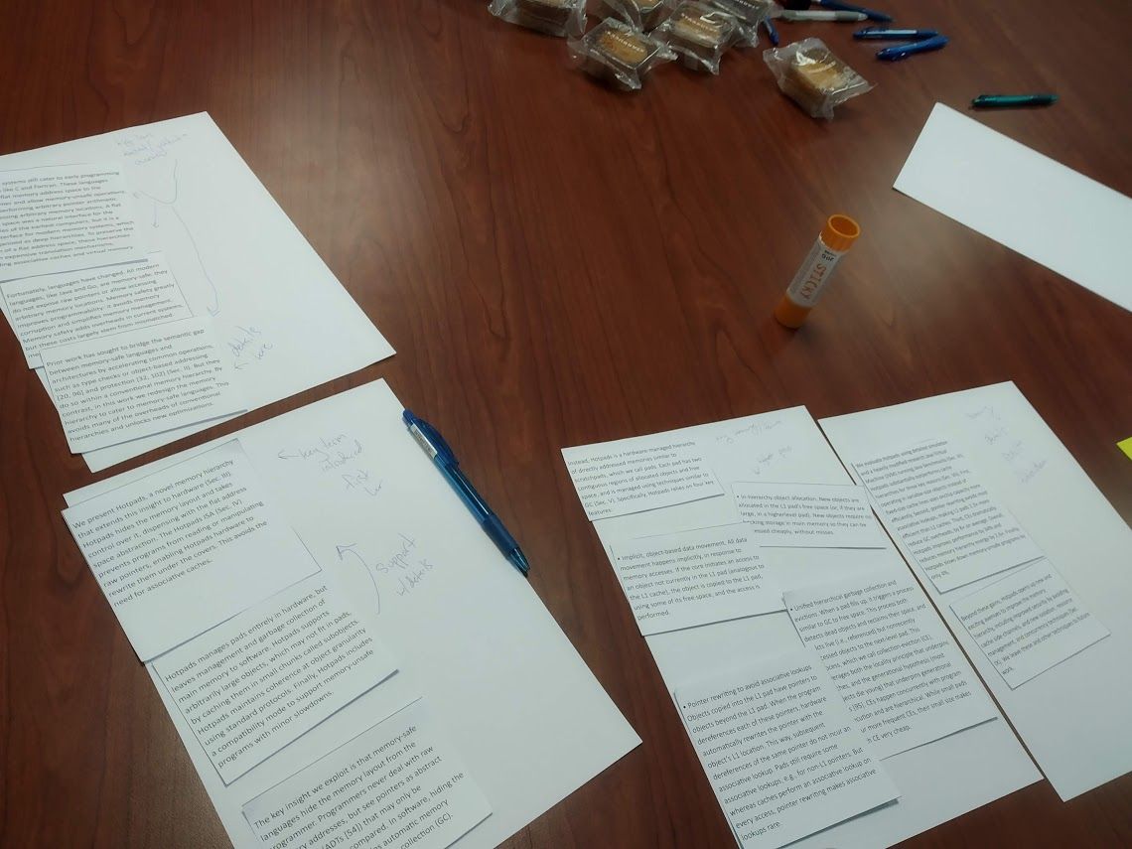
There is a certain rule. Our paper should be written in a way that makes it easy to be re-organized.

